**SEND MAIL**

**PROGRAM:**

import java.util.*;

import javax.mail.*;

import javax.mail.internet.*;

public class SendMail {

public static void main(String[] args) {

//Get the Properties and Create a default session

Properties prop = System.getProperties();

prop.setProperty("mail.server.com", "127.0.0.1");

Session session = Session.getDefaultInstance(prop);

try {

//Set the mail headers

MimeMessage msg = new MimeMessage(session);

msg.setFrom(new InternetAddress("karthik1@mailserver.com"));

msg.addRecipient(Message.RecipientType.TO, new InternetAddress("karthik2@mailserver.com"));

msg.setSubject("First Mail");

//Create the mime body and attachments

MimeBodyPart msgBody = new MimeBodyPart();

msgBody.setContent("Hello World", "text/html");

MimeBodyPart attFile = new MimeBodyPart();

attFile.attachFile("RecvMail.java");

Multipart partMsg = new MimeMultipart();

partMsg.addBodyPart(msgBody);

partMsg.addBodyPart(attFile);

msg.setContent(partMsg);

Transport.send(msg);

System.out.println("Message Successfully sent...");

} catch(Exception e) { e.printStackTrace(); }

}

}

**OUTPUT:**

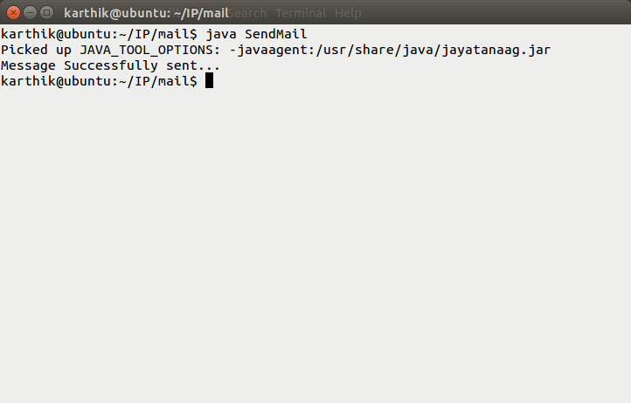

**RECEIVE MAIL**

**PROGRAM:**

import java.util.*;

import javax.mail.*;

public class RecvMail {

public static void main(String[] args) throws Exception{

Properties prop = System.getProperties();

prop.put("mail.pop3.host", "127.0.0.1");

Session session = Session.getDefaultInstance(prop);

Store store = session.getStore("pop3");

store.connect("karthik2@mailserver.com", "root");

Folder inbox = store.getFolder("INBOX");

inbox.open(Folder.READ_ONLY);

for(Message msg: inbox.getMessages()) {

System.out.println("Subject : " + msg.getSubject());

System.out.println("From: " + msg.getFrom()[0]);

System.out.println();

}

inbox.close(false);

store.close();

}

}

**OUTPUT:**

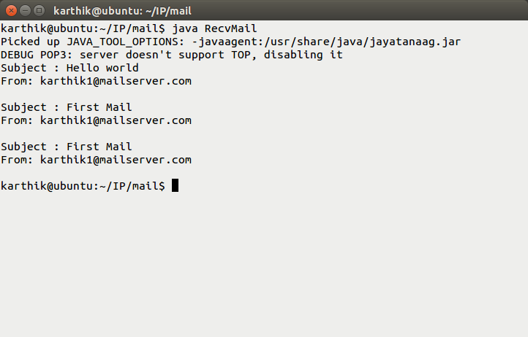

**RESULT:**

**THE ABOVE PROGRAM SUCCESSFULLY SENT AND RECEIVED MAILS.**

**FORM SERVLET COMMUNICATION:**

**PROGRAM:**

**FORM SERVLET.JAVA**

import java.io.*;

import javax.servlet.*;

import javax.servlet.http.*;

public class FormServlet extends HttpServlet {

public String setRow(String fName, String fValue) {

String row =

"<tr>" +

"<td>" + "<b>" + fName + "</b>" + "</td>" +

"<td>" + fValue + "</td>" +

"</tr>";

return row;

}

@Override

public void doGet(HttpServletRequest req, HttpServletResponse resp) {

String[] fieldNames = {

"pName",

"pTitle",

"pJob",

"pContact",

"pBday",

"pMobile",

"pEmail",

"pMarried"

};

String responseText = "<html><body><table>";

for(int i=0; i<fieldNames.length; i++) {

responseText += setRow(fieldNames[i], req.getParameter(fieldNames[i]));

}

responseText += "</body></html></table>";

try {

resp.setContentType("text/html");

PrintWriter out = resp.getWriter();

out.println(responseText);

} catch(Exception e) {e.printStackTrace();}

}

}

/*http://localhost:8080/FormServlet/?

pName=jbhjhbhj

&pTitle=hbjbhjb

&pJob=bhjh

&pContact=9487907066

&pBday=ds&pID=98

&pMobile=9487907066

&pEmail=fhjdkfh%40jkfh.com

&pMarried=Married#*/

**WEB.XML**

<web-app>

<servlet>

<servlet-name>FormServlet</servlet-name>

<servlet-class>FormServlet</servlet-class>

</servlet>

<servlet-mapping>

<servlet-name>FormServlet</servlet-name>

<url-pattern>/FormServlet</url-pattern>

</servlet-mapping>

<welcome-file-list>/index.html</welcome-file-list>

</web-app>

**INDEX.HTML**

<!DOCTYPE html>

<html>

<head>

<title>Form | Form Servlet Communication</title>

</head>

<body>

<form name="pForm" action="FormServlet" method="get" onsubmit="return validateForm()">

<fieldset>

<legend>Personal Information</legend>

<table>

<tr>

<td>Name

<td><input type="text" name="pName" title="Enter your name">

</tr>

<tr>

<td>Title

<td><input type="text" name="pTitle" title="Enter your title">

</tr>

<tr>

<td>Job

<td><input type="text" name="pJob" title="Enter your job">

</tr>

<tr>

<td>Contact

<td><input type="tel" name="pContact" title="Enter your contact's phone number">

</tr>

<tr>

<td>Birthday

<td><input type="date" name="pBday" title="Enter your date of birth">

</tr>

<tr>

<td>ID

<td><input type="number" name="pID" title="Enter your Person ID">

</tr>

<tr>

<td>Mobile

<td><input type="tel" name="pMobile" title="Enter your mobile number">

</tr>

<tr>

<td>Email

<td><input type="email" name="pEmail" title="Enter your e-mail id">

</tr>

<tr>

<td>Married

<td>

<input type="radio" name="pMarried" value="Married" title="If your are married">Married</input><br>

<input type="radio" name="pMarried" value="Single" title="If otherwise">Single</input>

</td>

</tr>

<tr>

<td> <input type="submit" value="submit" />

</tr>

</table>

</fieldset>

</form>

</body>

</html>

<script type="text/javascript">

function validateForm() {

var form = document.forms["pForm"];

var mobilePattern = new RegExp("[0-9]{10}");

var emailPattern = new RegExp("[a-zA-Z0-9_]+[@][a-zA-Z0-9_]+[.][a-zA-Z]+");

for(var i=1; i<form.length - 1; i++) {

if (form[i].value == "") {

window.alert("ALL FIELDS ARE MANDATORY");

return false;

}

switch (form[i].type) {

case "text": {

break;

}

case "tel": {

if (mobilePattern.test(form[i].value) == false) {

window.alert("INVALID PHONE NUMBER : " + form[i].value);

return false;

}

break;

}

case "email": {

if (emailPattern.test(form[i].value) == false) {

window.alert("INVALID MAIL : " + form[i].value);

return false;

}

break;

}

case "radio": {

var selected = false;

for(var j=0; j<form.length; j++) {

if(form[j].name == form[i].name && form[j].checked) {

selected = true;

}

}

if (!selected) {

window.alert("SELECT THE OPTIONS : " + form[i].name);

return false;

}

}

}

}

return true;

}

</script>

**OUTPUT:**

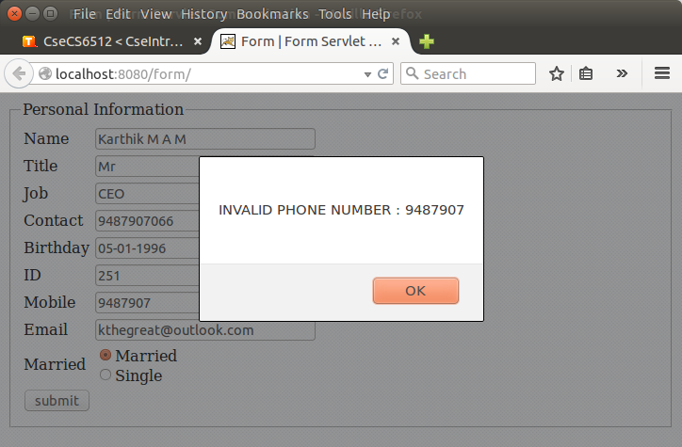

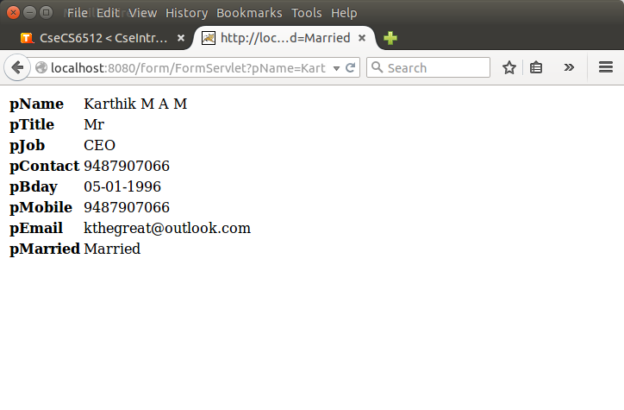

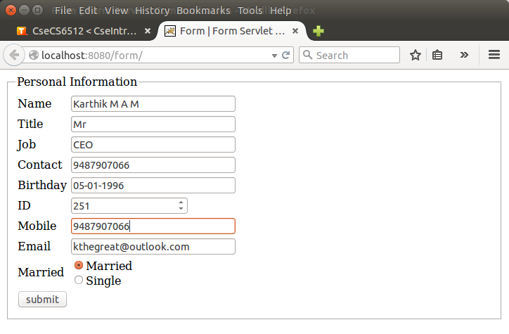

**RESULT:**

**THE ABOVE PROGRAM SUCCESSFULLY DEMONSTRATED THE FORM SERVLET COMMUNICATION.**

**STUDENT INFORMATION SYSTEM**

**PROGRAM:**

**INDEX.HTML**

<!DOCTYPE html>

<html>

<head>

<title>Student Information System</title>

</head>

<body>

<h4><center>Student Information System</center></h4>

<form name="detailsForm" action="StudentSystem" method="get">

<table>

<tr>

<td><button name="submit" value="Find" onclick="buttonClick()">Search</button></td>

<td><button name="submit" value="Add" onclick="buttonClick()">Add</button></td>

<td><button name="submit" value="Edit" onclick="buttonClick()">Edit</button></td>

<td><button name="submit" value="Delete" onclick="buttonClick()">Delete</button></td>

</tr>

</table>

<table>

<tr>

<td><b>ID</b></td>

<td><input type="text" name="id" /></td>

</tr>

<tr>

<td><b>Name</b></td>

<td><input type="text" name="name" /></td>

</tr>

<tr>

<td><b>Roll</b></td>

<td><input type="text" name="roll" /></td>

</tr>

<tr>

<td><b>Branch</b></td>

<td><input type="text" name="branch" /></td>

</tr>

<tr>

<td><b>Year</b></td>

<td><input type="text" name="year" /></td>

</tr>

<tr>

<td><b>Semester</b></td>

<td><input type="text" name="semester" /></td>

</tr>

<tr>

<td><b>DOB</b></td>

<td><input type="text" name="dob" /></td>

</tr>

<tr>

<td><b>Address</b></td>

<td><input type="text" name="address" /></td>

</tr>

</table>

</form>

</body>

</html>

<script type="text/javascript">

</script>

**WEB.XML**

<web-app>

<servlet>

<servlet-name>StudentSystem</servlet-name>

<servlet-class>StudentSystem</servlet-class>

</servlet>

<servlet-mapping>

<servlet-name>StudentSystem</servlet-name>

<url-pattern>/StudentSystem</url-pattern>

</servlet-mapping>

<welcome-file-list>/index.html</welcome-file-list>

</web-app>

**STUDENT SYSTEM.JAVA**

import java.io.*;

import javax.servlet.*;

import javax.servlet.http.*;

import java.sql.*;

public class StudentSystem extends HttpServlet {

static final String JDBC_DRIVER = "com.mysql.jdbc.Driver";

static final String DB_URL = "jdbc:mysql://localhost/db";

static final String USER = "root";

static final String PASS = "2309";

private String id;

private String name;

private String roll;

private String branch;

private String year;

private String semester;

private String dob;

private String address;

private String submit;

public void doGet(HttpServletRequest req, HttpServletResponse res) {

id = req.getParameter("id");

name = req.getParameter("name");

roll = req.getParameter("roll");

branch = req.getParameter("branch");

year = req.getParameter("year");

semester = req.getParameter("semester");

dob = req.getParameter("dob");

address = req.getParameter("address");

submit = req.getParameter("submit");

try {

Connection con = null;

PreparedStatement stmt = null;

Class.forName(JDBC_DRIVER);

con = DriverManager.getConnection(DB_URL, USER, PASS);

switch(submit) {

case "Add": {

stmt = con.prepareStatement("insert into student values(?, ?, ?, ?, ?, ?, ?, ?);");

stmt.setString(1, id);

stmt.setString(2, name);

stmt.setString(3, roll);

stmt.setString(4, branch);

stmt.setString(5, year);

stmt.setString(6, semester);

stmt.setString(7, dob);

stmt.setString(8, address);

stmt.execute();

break;

}

case "Edit": {

stmt = con.prepareStatement("update student set name = ?, roll = ?, branch = ?, year = ?, semester = ?, dob = ?, address = ? where id = ?;");

stmt.setString(8, id);

stmt.setString(1, name);

stmt.setString(2, roll);

stmt.setString(3, branch);

stmt.setString(4, year);

stmt.setString(5, semester);

stmt.setString(6, dob);

stmt.setString(7, address);

stmt.execute();

break;

}

case "Delete": {

stmt = con.prepareStatement("delete from student where id=?");

stmt.setString(1, id);

stmt.execute();

break;

}

default: {

break;

}

}

stmt = con.prepareStatement("select * from student where id=?");

stmt.setString(1, id);

ResultSet result = stmt.executeQuery();

if(result.next()) {

id = result.getString(1);

name = result.getString(2);

roll = result.getString(3);

branch = result.getString(4);

year = result.getString(5);

semester = result.getString(6);

dob = result.getString(7);

address = result.getString(8);

}

res.getWriter().printf(htmlDoc, id, name, roll, branch, year, semester, dob, address, submit + " Successful!");

} catch(Exception e) { }

}

static public String htmlDoc =

"<!DOCTYPE html>

" +

"

<html>

" +

"

<head>

" +

"

<title>Student Information System</title>" +

"

</head>" +

"

<body>

" +

"<h4><center>Student Information System</center></h4>" +

"<form name=\"detailsForm\" action=\"StudentSystem\" method=\"get\">

" +

"<table>

" +

"

<tr>

" +

"

<td><button name=\"submit\" value=\"Find\" onclick=\"buttonClick()\">Search</button></td>" +

"

<td><button name=\"submit\" value=\"Add\" onclick=\"buttonClick()\">Add</button></td>" +

"

<td><button name=\"submit\" value=\"Edit\" onclick=\"buttonClick()\">Edit</button></td>" +

"

<td><button name=\"submit\" value=\"Delete\" onclick=\"buttonClick()\">Delete</button></td>" +

"

</tr>" +

"

</table>" +

"<table>

" +

"

<tr>

" +

"

<td><b>ID</b></td>" +

"

<td><input type=\"text\" name=\"id\" value=\"%s\" /></td>" +

"

</tr>" +

"

<tr>

" +

"

<td><b>Name</b></td>" +

"

<td><input type=\"text\" name=\"name\" value=\"%s\" /></td>" +

"

</tr>" +

"

<tr>

" +

"

<td><b>Roll</b></td>" +

"

<td><input type=\"text\" name=\"roll\" value=\"%s\" /></td>" +

"

</tr>" +

"

<tr>

" +

"

<td><b>Branch</b></td>" +

"

<td><input type=\"text\" name=\"branch\" value=\"%s\" /></td>" +

"

</tr>" +

"

<tr>

" +

"

<td><b>Year</b></td>" +

"

<td><input type=\"text\" name=\"year\" value=\"%s\" /></td>" +

"

</tr>" +

"

<tr>

" +

"

<td><b>Semester</b></td>" +

"

<td><input type=\"text\" name=\"semester\" value=\"%s\" /></td>" +

"

</tr>" +

"

<tr>

" +

"

<td><b>DOB</b></td>" +

"

<td><input type=\"text\" name=\"dob\" value=\"%s\" /></td>" +

"

</tr>" +

"

<tr>

" +

"

<td><b>Address</b></td>" +

"

<td><input type=\"text\" name=\"address\" value=\"%s\" /></td>" +

"

</tr>" +

"

</table>" +

"<p>%s</p>" +

"

</form>" +

"

</body>" +

"

</html>";

}

**OUTPUT:**

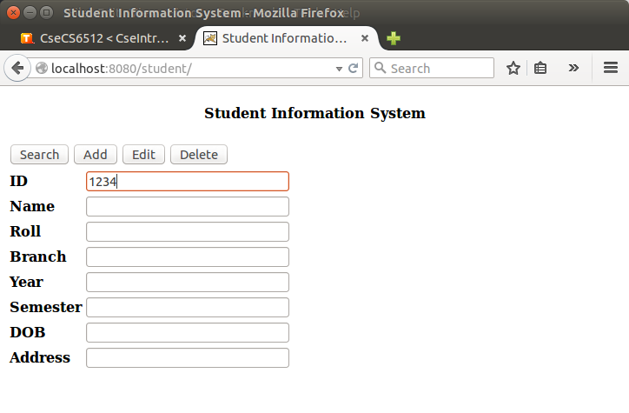

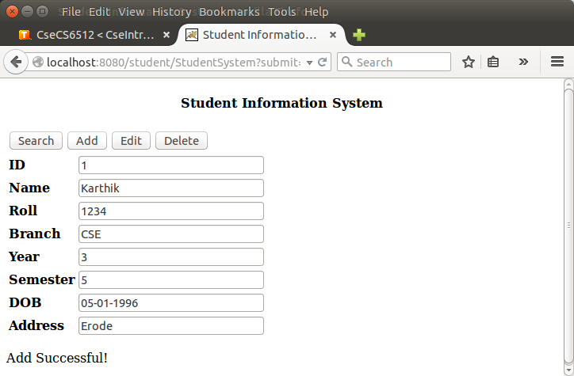

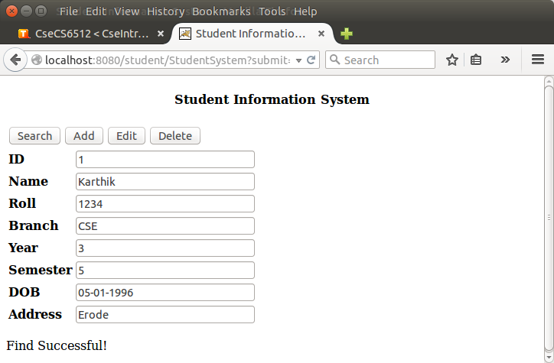

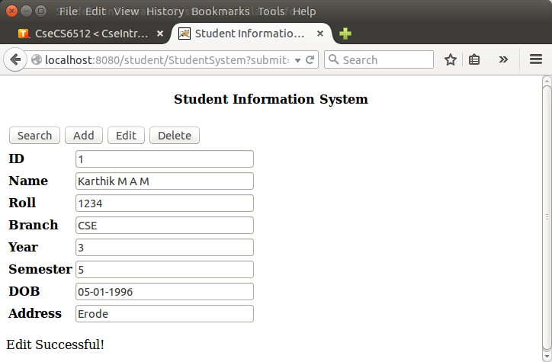

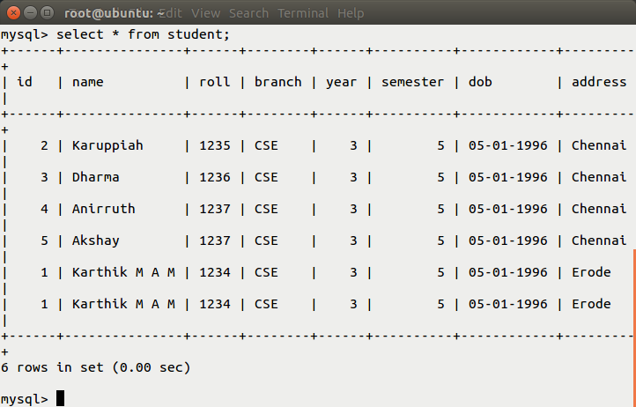

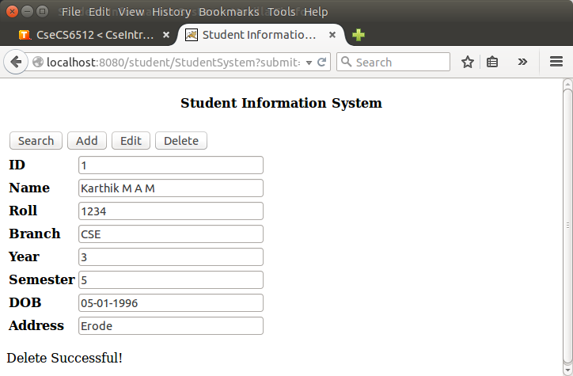

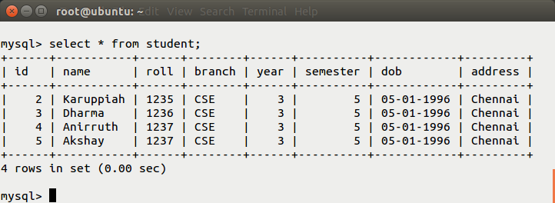

**RESULT:**

**THE STUDENT INFO SYSTEM WAS SUCCESSFULLY CREATED.**

**APPLET TO SERVLET COMMUNICATION**

**PROGRAM:**

**APPLET CLASS.JAVA**

import java.applet.*;

import java.awt.*;

import java.awt.event.*;

import java.io.*;

import java.net.*;

public class AppletClass extends Applet implements ActionListener{

private TextField txtUser = new TextField(10);

private TextField txtPass = new TextField(10);

private TextField txtResult = new TextField(10);

private Button btnSend = new Button("Send");

public void init() {

add(txtUser);

add(txtPass);

add(btnSend);

add(txtResult);

btnSend.addActionListener(this);

txtResult.setEditable(false);

}

public void actionPerformed(ActionEvent e) {

try {

URL url = new URL(getCodeBase(), "ServletClass");

URLConnection con = url.openConnection();

con.setDoInput(true);

con.setDoOutput(true);

con.setUseCaches(false);

con.setRequestProperty("Content-Type", "application/x-java-serialized-object");

ObjectOutputStream out = new ObjectOutputStream(con.getOutputStream());

out.writeObject(txtUser.getText());

out.writeObject(txtPass.getText());

out.flush();

out.close();

ObjectInputStream in = new ObjectInputStream(con.getInputStream());

txtResult.setText((String) in.readObject());

} catch(Exception ex) { txtResult.setText(ex.getMessage()); }

}

}

**SERVLET CLASS.JAVA**

import java.io.*;

import javax.servlet.*;

import javax.servlet.http.*;

public class ServletClass extends HttpServlet {

public void doPost(HttpServletRequest req, HttpServletResponse res) {

try {

ObjectInputStream in = new ObjectInputStream(req.getInputStream());

String user = (String) in.readObject();

String pass = (String) in.readObject();

String result = "Failure";

if("karthik".equals(user) && "karthik".equals(pass)) {

result = "Success";

}

res.setContentType("application/x-java-serialized-object");

ObjectOutputStream out = new ObjectOutputStream(res.getOutputStream());

out.writeObject(result);

out.flush();

out.close();

} catch(Exception e) {}

}

}

**INDEX.HTML**

<!DOCTYPE html>

<html>

<body>

<center>

<applet code="AppletClass" width="400" height="100"></applet>

</center>

</body>

</html>

**WEB.XML**

<web-app>

<servlet>

<servlet-name>ServletClass</servlet-name>

<servlet-class>ServletClass</servlet-class>

</servlet>

<servlet-mapping>

<servlet-name>ServletClass</servlet-name>

<url-pattern>/ServletClass</url-pattern>

</servlet-mapping>

<welcome-file-list>/index.html</welcome-file-list>

</web-app>

**OUTPUT:**

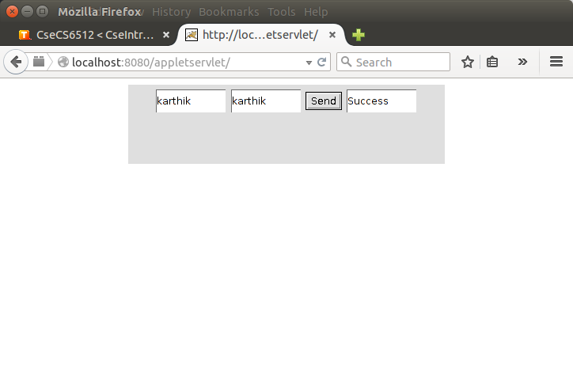

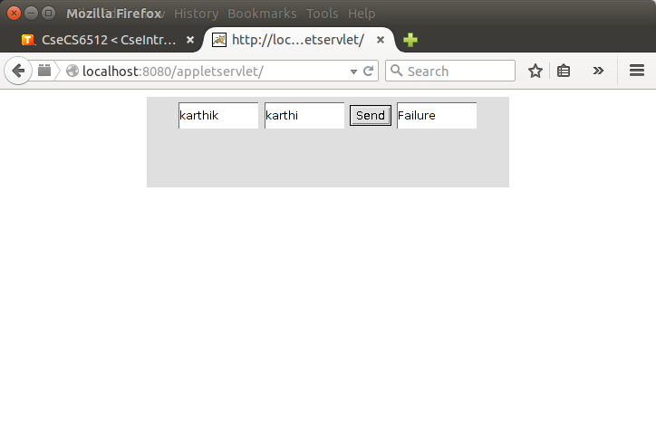

**RESULT:**

**THE APPLET TO SERVLET COMMUNICATION WAS ESTABLISHED.**

**SESSION VISIT COUNTER:**

**PROGRAM:**

**INDEX.JSP**

<%@ page import="java.io.*" %>

<!DOCTYPE html>

<html>

<head>

<title>Session Tracking</title>

</head>

<body>

<center>

<%

int visitCount = 0;

String visitCountKey = "visitCount";

if(session.isNew()) {

session.setAttribute(visitCountKey, visitCount);

}

visitCount = (int)session.getAttribute(visitCountKey) + 1;

session.setAttribute(visitCountKey, visitCount);

%>

<% out.println("Visit Count : " + visitCount); %>

</center>

</body>

</html>

**WEB.XML**

<web-app>

<servlet>

<servlet-name>index</servlet-name>

<jsp-file>/index.jsp</jsp-file>

</servlet>

<servlet-mapping>

<servlet-name>index</servlet-name>

<url-pattern>/index.jsp</url-pattern>

</servlet-mapping>

<welcome-file-list>index.jsp</welcome-file-list>

</web-app>

**OUTPUT:**

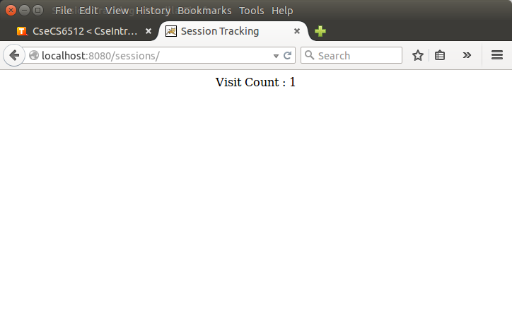

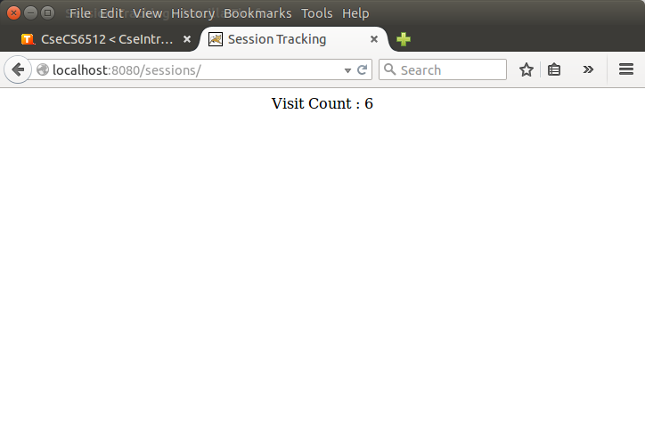

**RESULT:**

**THE HIT COUNTER USING JSP SESSIONS WAS SIMULATED.**

**ONLINE EXAM USING JSP**

**PROGRAM:**

**INDEX.JSP**

<%@ page import="java.sql.*,java.io.*"%>

<%

String JDBC_DRIVER = "com.mysql.jdbc.Driver";

String DB_URL = "jdbc:mysql://localhost/db";

String USER = "root";

String PASS = "2309";

%>

<!DOCTYPE html>

<html>

<head>

<title>Questions</title>

</head>

<body>

<h3><center>Online Test</h3></center>

<%

try {

Connection con = null;

ResultSet questions = null;

ResultSet options = null;

Class.forName(JDBC_DRIVER);

con = DriverManager.getConnection(DB_URL, USER, PASS);

questions = con.prepareStatement("select * from questions").executeQuery();

options = con.prepareStatement("select * from options").executeQuery();

out.println("<form action='results.jsp' method='get'>

");

while(questions.next()) {

out.println("<b>

" + questions.getString(1) + ". " + questions.getString(2) + " <b>

<br>");

for(int i=0; i<3; i++) {

options.next();

out.println("<input type='radio' name='" + questions.getString(1) + "'" + "value='" + options.getString(2) + "'>");

out.println((i + 1) + ". " + options.getString(2) + "<br>");

out.println("</input>");

}

out.println("<br>");

}

out.println("<input type='submit' value='Check Results'>");

out.println("

</form>");

} catch (Exception e) {

e.printStackTrace();

}

%>

</body>

</html>

**RESULTS.JSP**

<%@ page import="java.sql.*,java.io.*" %>

<%

String JDBC_DRIVER = "com.mysql.jdbc.Driver";

String DB_URL = "jdbc:mysql://localhost/db";

String USER = "root";

String PASS = "2309";

%>

<!DOCTYPE html>

<html>

<head>

<title>Results</title>

</head>

<body>

<%

Connection con = null;

ResultSet answers = null;

Class.forName(JDBC_DRIVER);

con = DriverManager.getConnection(DB_URL, USER, PASS);

answers = con.prepareStatement("select * from answers;").executeQuery();

int score = 0;

while(answers.next()) {

String userAns = request.getParameter(answers.getString(1));

if(userAns != null && userAns.equals(answers.getString(2))) {

score++;

}

}

%>

<center>

<h4><%= "Your Score is " + score %></h4>

</center>

</body>

</html>

**WEB.XML**

<web-app>

<servlet>

<servlet-name>Questions</servlet-name>

<jsp-file>/index.jsp</jsp-file>

</servlet>

<servlet-mapping>

<servlet-name>Questions</servlet-name>

<url-pattern>/index.jsp</url-pattern>

</servlet-mapping>

<servlet>

<servlet-name>Results</servlet-name>

<jsp-file>/results.jsp</jsp-file>

</servlet>

<servlet-mapping>

<servlet-name>Results</servlet-name>

<url-pattern>/results.jsp</url-pattern>

</servlet-mapping>

<welcome-file-list>/index.jsp</welcome-file-list>

</web-app>

**OUTPUT:**

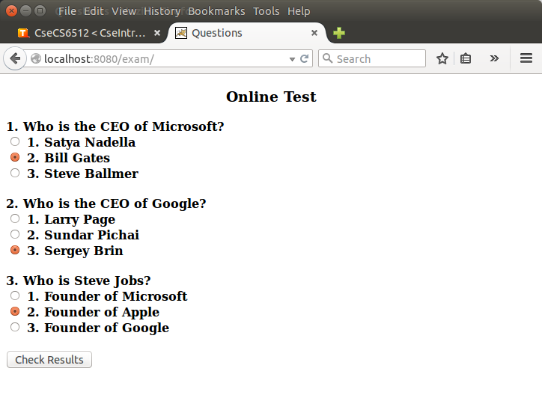

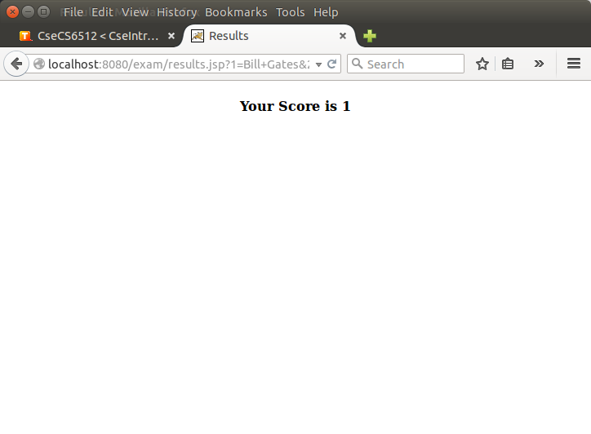

**RESULT:**

**THE ONLINE EXAM WEB-APP WAS SUCCESSFULLY CREATED.**

**XML DOM**

**PROGRAM:**

import java.io.*;

import javax.xml.parsers.*;

import org.w3c.dom.*;

public class XmlParser {

public static void main(String[] args) {

try {

File xmlFile = new File("sample.xml");

Document xmlDoc = DocumentBuilderFactory

.newInstance()

.newDocumentBuilder()

.parse(xmlFile);

xmlDoc.getDocumentElement().normalize();

NodeList nodeList = xmlDoc.getElementsByTagName("book");

for(int i=0; i<nodeList.getLength(); i++) {

Element element = (Element)nodeList.item(i);

System.out.println("Author : " + element

.getElementsByTagName("author")

.item(0)

.getTextContent());

}

} catch (Exception e) { e.printStackTrace(); }

}

}

**OUTPUT:**

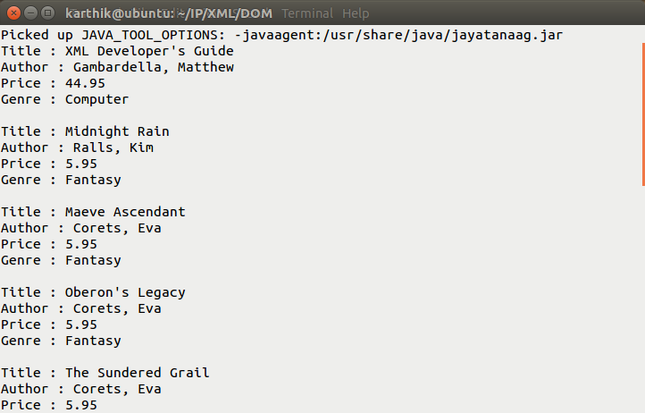

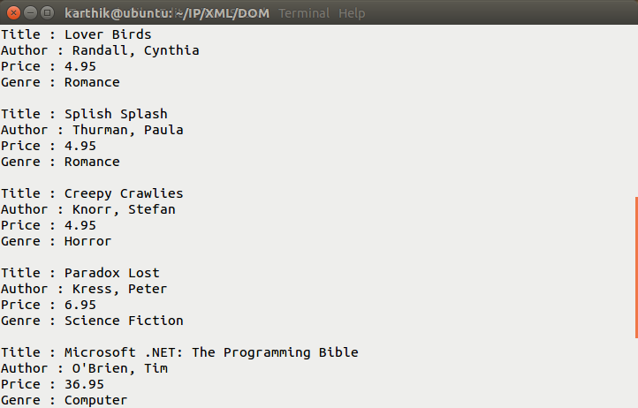

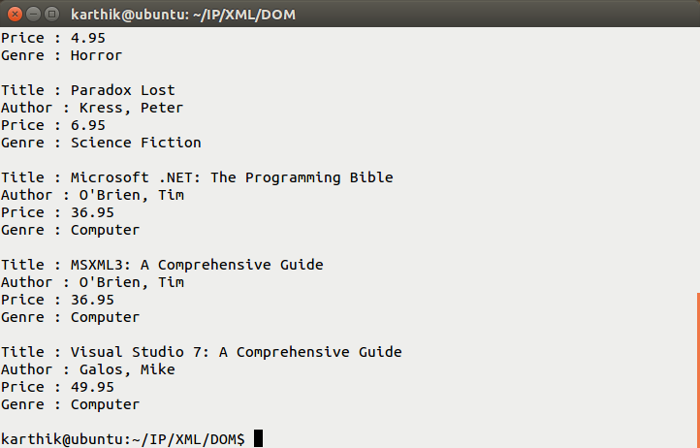

**RESULT:**

**THE XML WAS PARSED USING DOM.**

**XML XSLT:**

**PROGRAM:**

**SELECT A GENRE**

<?xml version="1.0" encoding="UTF-8"?>

<xsl:stylesheet version="1.0" xmlns:xsl="http://www.w3.org/1999/XSL/Transform">

<xsl:template match="/">

<html>

<body>

<table>

<tr>

<th>Title</th>

<th>Genere</th>

</tr>

<xsl:for-each select="catalog/book[genre='Computer']">

<xsl:sort select="title"/>

<tr>

<td><xsl:value-of select="title"/></td>

<td><xsl:value-of select="genre"/></td>

</tr>

</xsl:for-each>

</table>

</body>

</html>

</xsl:template>

</xsl:stylesheet>

**SELECT A PRICE RANGE**

<?xml version="1.0" encoding="UTF-8"?>

<xsl:stylesheet version="1.0" xmlns:xsl="http://www.w3.org/1999/XSL/Transform">

<xsl:template match="/">

<html>

<body>

<table>

<tr>

<th>Title</th>

<th>Price</th>

</tr>

<xsl:for-each select="catalog/book">

<xsl:if test="not(price > 50) and (price > 10)">

<tr>

<td><xsl:value-of select="title"/></td>

<td><xsl:value-of select="price"/></td>

</tr>

</xsl:if>

</xsl:for-each>

</table>

</body>

</html>

</xsl:template>

</xsl:stylesheet>

**SORT AND DISPLAY**

<?xml version="1.0" encoding="UTF-8"?>

<xsl:stylesheet version="1.0" xmlns:xsl="http://www.w3.org/1999/XSL/Transform">

<xsl:template match="/">

<html>

<body>

<table>

<tr>

<th>Title</th>

<th>Author</th>

</tr>

<xsl:for-each select="catalog/book">

<xsl:sort select="title"/>

<tr>

<td><xsl:value-of select="title"/></td>

<td><xsl:value-of select="author"/></td>

</tr>

</xsl:for-each>

</table>

</body>

</html>

</xsl:template>

</xsl:stylesheet>

**CONCATENATION OF AUTHOR AND TITLE**

<?xml version="1.0" encoding="UTF-8"?>

<xsl:stylesheet version="1.0" xmlns:xsl="http://www.w3.org/1999/XSL/Transform">

<xsl:template match="/">

<html>

<body>

<xsl:for-each select="catalog/book">

<xsl:value-of select="title"/>

<xsl:value-of select="author"/>

<br/>

</xsl:for-each>

</body>

</html>

</xsl:template>

</xsl:stylesheet>

**OUTPUT:**

**CONCAT.XSL**

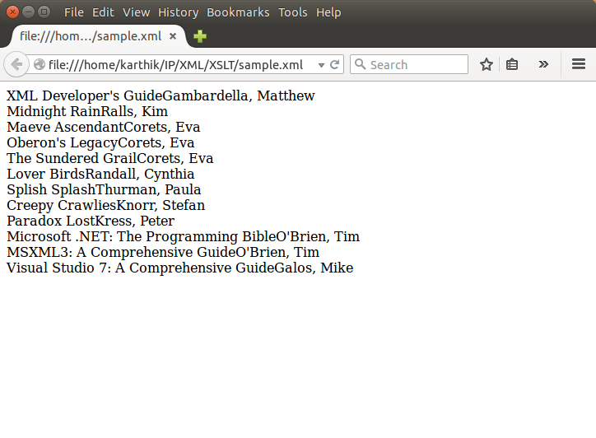

**GENRE.XSL**

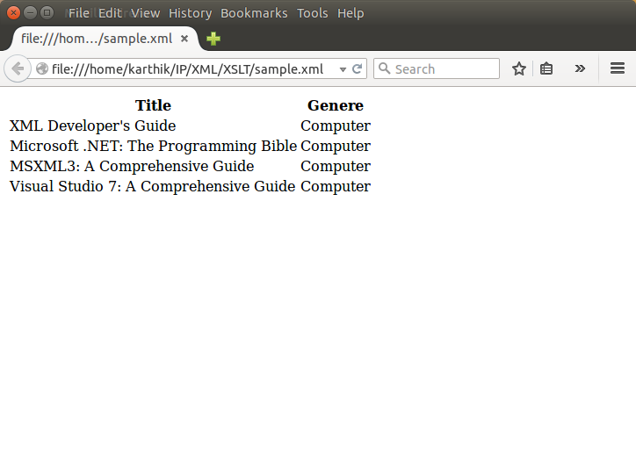

**RANGE.XSL**

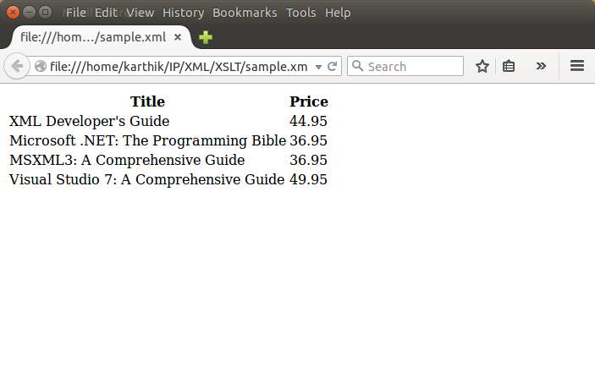

**SORT.XSL**

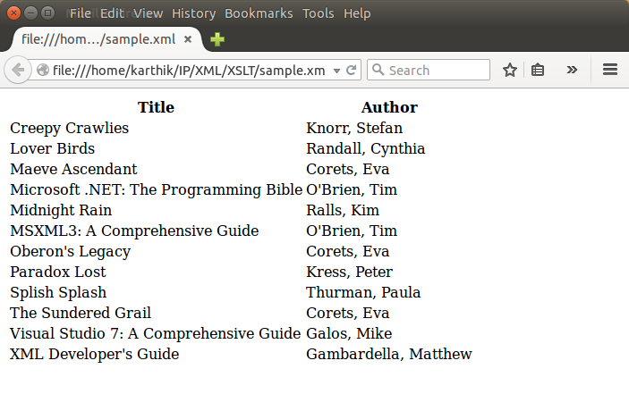

**TABLE.XSL**

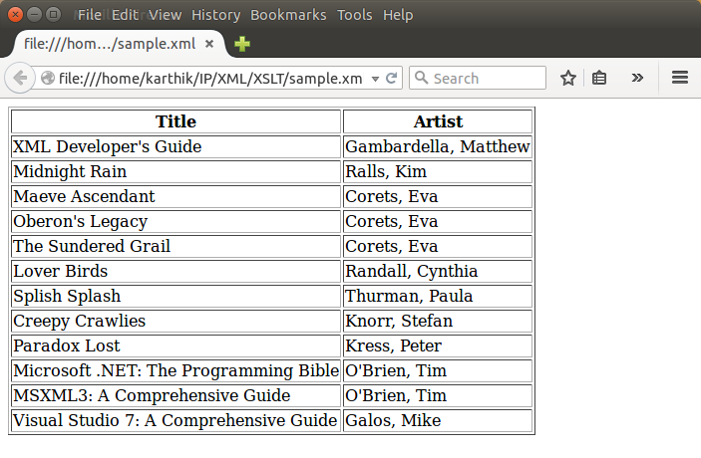

**RESULT:**

**THE XSL STYLESHEET WAS USED TO DISPLAY A FORMATTED XML DOCUMENT.**